

**INTERNSHIP PROJECT REPORT**

**ENCRYPTNG AND DECRYPTING**

***SUBMITTED BY***

**NISHANTH R – 1RN19CS090**

**PRIYANKA B A – 1RN19CS103**

**FROM**

**RNS INSTITUTE OF TECHNOLOGY**

***In fulfillment of training at IT department***

**IN**

**AIRCARFT DIVISION**

**HINDUSTAN AERONAUTICS LIMITED**

**BANGALORE**

**FEBRUARY 2023**

**ACKNOWLEDGEMENT**

We would like to take this opportunity to express our heartfelt gratitude to Hindustan Aeronautics Limited Bangalore for providing us with the invaluable opportunity to intern at the IT department of the Aircraft Division. The experience that we gained during my internship has been truly enriching and has allowed us to apply our knowledge and skills in a real-world setting. The guidance and support that we received from our mentors and colleagues at HAL have been invaluable in shaping our understanding of the industry and enhancing our professional growth. We are grateful to HAL for providing us with this platform to learn, explore, and grow as an individual. Thank you once again, HAL Bangalore, for the incredible opportunity and for contributing towards our career development.

#### Nishanth R 1RN19CS090

**Priyanka B A 1RN19CS103**

**ABSTRACT**

Message encryption and decryption is the process of transforming plain text messages into encoded ciphertext, which can only be understood by authorized recipients with the appropriate decryption key. This technique is used to secure sensitive information such as financial transactions, personal data, and classified documents. Encryption algorithms use complex mathematical equations and keys to scramble the message, making it unreadable to unauthorized users. Decryption is the reverse process of encryption and involves using the decryption key to convert the ciphertext back into plain text. This abstract provides a brief overview of message encryption and decryption, highlighting its importance in ensuring the confidentiality and integrity of sensitive information.

**TABLE OF CONTENTS**

|  |  |  |
| --- | --- | --- |
| Sl. No. | Chapter Name | Page No |
|  | Acknowledgement | i |
| 1 | Abstract  Table of Contents  **INTRODUCTION** | ii  iii  01 |
| 2  3  4  5  6  7 | 1.1 Aircraft Division  1.2 Departments of Aircraft Division  1.3 IT Department  1.4 Network and System Administration  1.5 Software Development and Support  1.6 Cyber Security  1.7 Helpdesk Support  1.8 Education and Training  **WHAT WE LEARNT AT HAL**  **PROBLEM STATEMENT**  3.1 Proposed System  3.2 Prerequisites for the Project  3.3 Steps for Building Python Message Encryption and …..Decryption Project  **IMPLEMENTATION**  **RESULTS/SNAPSHOTS**  **CONCLUSIONS AND FUTURE WORK**  6.1 Future Work  **REFERENCES** | 02  03  04  05  06  07  08  09  10  15  16  17  18  19  20  25  26  27 |

**CHAPTER 1**

**INTRODUCTION**

Hindustan Aeronautics Limited (HAL) is a state-owned aerospace and defense company headquartered in Bangalore, India. Founded in 1940, HAL is one of the largest aerospace companies in Asia and has played a significant role in the development of India's indigenous aviation industry.

HAL designs, develops, manufactures, and maintains aircraft, helicopters, engines, and related components for military and civilian use. Its major products include fighter aircraft like the Sukhoi Su-30MKI, the Light Combat Aircraft (LCA) Tejas, and the Advanced Light Helicopter (ALH) Dhruv.

HAL has a vast infrastructure consisting of production facilities, research and development centers, and design centers spread across India. The company has collaborations with leading global aerospace companies, such as Boeing, Airbus, and Rolls-Royce, and has exported its products to more than 30 countries.

HAL has been recognized with several awards for its contributions to the Indian aerospace industry, including the National Award for R&D in Aerospace and the Raksha Mantri's Award for Excellence in Indigenization of Aerospace Technology.

Hindustan Aeronautics Limited (HAL) has several divisions that are involved in the design, development, production, and maintenance of aerospace products. Here are some of the key divisions of HAL:

**Aircraft Division:** This division is responsible for the design, development, and production of fixed-wing aircraft, including fighter jets, transport aircraft, and trainers.

**Helicopter Division:** This division is responsible for the design, development, and production of rotary-wing aircraft, including helicopters and unmanned aerial vehicles (UAVs).

**Engine Division:** This division is responsible for the design, development, and production of aircraft engines, including jet engines, turboprop engines, and turboshaft engines.

**Aerospace Division:** This division is responsible for the manufacture of aerospace structures and components, including fuselages, wings, and landing gears.

**Accessories Division:** This division is responsible for the manufacture of aircraft accessories and avionics, including navigation systems, communication systems, and electronic warfare systems.

**R&D Centers:** HAL has several research and development centers that are involved in cutting-edge research in areas such as aerodynamics, materials science, and propulsion technology.

Overall, these divisions work in tandem to develop a wide range of aerospace products for both military and civilian use, contributing to the growth of India's indigenous aerospace industry.

**1.1 AIRCRAFT DIVISION:**

HAL Aircraft Division is one of the key divisions of Hindustan Aeronautics Limited (HAL), a state-owned aerospace and defense company based in Bangalore, India. The Aircraft Division is responsible for the design, development, and production of fixed-wing aircraft, including fighter jets, transport aircraft, and trainers.

The Aircraft Division has several production facilities across India, including in Bangalore, Nasik, and Korwa. Some of the notable products developed by the Aircraft Division include:

**Sukhoi Su-30MKI:** The Sukhoi Su-30MKI is a twin-engine, multirole fighter aircraft developed jointly by HAL and Russia's Sukhoi Aviation Corporation. It is the backbone of the Indian Air Force's fighter fleet.

**Light Combat Aircraft (LCA) Tejas:** The LCA Tejas is a single-engine, lightweight, multirole fighter aircraft developed by HAL. It is designed to replace the aging fleet of MiG-21 and MiG-27 aircraft of the Indian Air Force.

**Dornier Do 228:** The Dornier Do 228 is a twin-turboprop, short takeoff and landing (STOL) aircraft developed by HAL. It is used for a variety of missions, including passenger transport, cargo transport, and maritime surveillance.

**Hawk Advanced Jet Trainer:** The Hawk Advanced Jet Trainer is a tandem-seat, single-engine trainer aircraft developed jointly by HAL and BAE Systems. It is used by the Indian Air Force and the Indian Navy for pilot training.

Overall, the Aircraft Division of HAL has played a significant role in the development of India's indigenous aerospace industry and has contributed to the country's defense capabilities.

**1.2 DEPARTMENTS OF AIRCRAFT DIVISION:**

The Aircraft Division of Hindustan Aeronautics Limited (HAL) has several departments that work together to design, develop, and produce fixed-wing aircraft. Here are some of the key departments of the Aircraft Division at HAL:

**Design Department:** This department is responsible for the conceptualization and design of aircraft, including aerodynamic design, structural design, and system design.

**Manufacturing Department:** This department is responsible for the production of aircraft, including the manufacture of aircraft components and subassemblies.

**Flight Test Department:** This department is responsible for flight testing of aircraft, including flight testing of prototypes and production aircraft.

**Quality Assurance Department:** This department is responsible for ensuring that all aircraft produced by HAL meet the required quality standards.

**Materials Department:** This department is responsible for the procurement and management of materials required for aircraft production, including raw materials, components, and subassemblies.

**Engineering Department:** This department is responsible for providing engineering support to the other departments, including design, manufacturing, and flight testing.

**Maintenance, Repair, and Overhaul (MRO) Department:** This department is responsible for the maintenance, repair, and overhaul of aircraft produced by HAL, as well as for providing MRO services to other aircraft operators.

**IT Department:** The Hindustan Aeronautics Limited (HAL) Aircraft Division's IT department plays a significant role in supporting the division's operations and workflows through the use of information technology.

Overall, these departments work together to ensure the successful design, development, and production of fixed-wing aircraft by HAL.

**1.3 IT DEPARTMENT:**

The IT department at the Aircraft Division of Hindustan Aeronautics Limited (HAL) plays an important role in supporting the division's operations and processes through the use of information technology. The IT department is responsible for managing the division's computer systems, networks, and software applications, as well as for providing technical support and training to the division's employees.

Some of the key functions of the IT department at the Aircraft Division of HAL include:

**Network and System Administration**: The IT department is responsible for maintaining the division's computer networks and servers, as well as ensuring that all hardware and software systems are functioning properly.

**Software Development and Support:** The IT department develops and maintains software applications used by the division, including design and simulation software, project management tools, and other custom applications.

**Cybersecurity:** The IT department is responsible for ensuring the security of the division's computer systems and data, including implementing firewalls, intrusion detection systems, and other security measures.

**Helpdesk Support:** The IT department provides technical support and assistance to the division's employees for any IT-related issues or problems.

**Training and Education:** The IT department provides training and education to the division's employees on the use of IT systems and software, as well as on cybersecurity best practices.

Overall, the IT department at the Aircraft Division of HAL plays a crucial role in ensuring the smooth and efficient operation of the division's processes, as well as the security and integrity of its data and systems.

**1.4 NETWORK AND SYSTEM ADMINISTRATION:**

Network and system administration is an important responsibility of the IT Department at Hindustan Aeronautics Limited (HAL). The Network and System Administration team is responsible for managing and maintaining the computer systems and networks used by the organization. This involves a range of activities, including:

**Hardware and software installation:** The Network and System Administration team installs and configures hardware and software systems, such as servers, network switches, routers, and operating systems.

**Network monitoring and management:** The team monitors the network for any issues or disruptions and takes necessary measures to resolve them. They also manage network bandwidth to ensure optimal performance.

**Backup and recovery:** The team ensures that all data on the network is regularly backed up and can be recovered in the event of a disaster or system failure.

**Security management:** The team is responsible for implementing and maintaining security measures such as firewalls, antivirus software, intrusion detection systems, and access controls.

**System maintenance and updates:** The team regularly maintains and updates the systems to ensure they are functioning properly and have the latest security patches and updates installed.

**User account management:** The team manages user accounts, permissions, and access to ensure that only authorized users have access to sensitive data and systems.

**Documentation and reporting:** The team maintains documentation of the network and system configurations, processes, and procedures. They also provide regular reports to management on the performance and security of the network and systems.

Overall, the Network and System Administration team at HAL plays a crucial role in ensuring the smooth functioning of the organization's technology systems and networks.

**1.5 SOFTWARE DEVELOPMENT AND SUPPORT:**

Software Development and Support is an important function of the IT Department at Hindustan Aeronautics Limited (HAL). The Software Development and Support team is responsible for developing and maintaining software applications that support the organization's operations, as well as providing technical support for these applications. This involves a range of activities, including:

**Software design and development:** The team designs, develops, and tests software applications that meet the requirements of the organization, such as design and simulation software, project management tools, and custom applications.

**Software maintenance and updates:** The team maintains and updates existing software applications to ensure they are functioning properly and have the latest security patches and updates installed.

**Integration and testing:** The team integrates new software applications with existing systems and conducts thorough testing to ensure they function properly.

**Technical support:** The team provides technical support to users of software applications, assisting with troubleshooting, bug fixes, and user access and permissions.

**Documentation:** The team maintains documentation of software applications, including user manuals and technical specifications.

**Training:** The team provides training to users of software applications to ensure they can use them effectively and efficiently.

Overall, the Software Development and Support team at HAL plays a critical role in ensuring the organization has the software applications it needs to support its operations, as well as providing technical support to users to ensure the applications function properly.

**1.6 CYBERSECURITY:**

Cybersecurity is an essential function of the IT Department at Hindustan Aeronautics Limited (HAL). The Cybersecurity team is responsible for protecting the organization's information, assets, and technology systems from cybersecurity threats, such as viruses, malware, hacking, and data breaches. This involves a range of activities, including:

**Risk assessment:** The team conducts regular risk assessments to identify potential cybersecurity threats and vulnerabilities within the organization.

**Security policy development and implementation**: The team develops and implements security policies and procedures to ensure the protection of the organization's information and technology systems.

**Access control management:** The team manages access control to the organization's technology systems to ensure only authorized personnel have access.

**Security monitoring and incident response:** The team monitors the organization's systems for any signs of cybersecurity threats and responds to incidents to minimize damage and prevent further attacks.

**Security training and awareness**: The team provides cybersecurity training to employees to raise awareness of cybersecurity threats and best practices for protecting sensitive information.

**Network and system security:** The team implements and maintains security measures such as firewalls, intrusion detection and prevention systems, and antivirus software to protect the organization's networks and systems from cyber threats.

**Data protection and encryption:** The team implements measures to protect sensitive data, such as encryption, secure storage, and regular backups.

Overall, the Cybersecurity team at HAL plays a critical role in ensuring the security and integrity of the organization's information, assets, and technology systems.

**1.7 HELPDESK SUPPORT:**

Helpdesk Support is an important function of the IT Department at Hindustan Aeronautics Limited (HAL). The Helpdesk Support team is responsible for providing technical assistance and support to employees who are experiencing issues with their computer systems or software applications. This involves a range of activities, including:

**Troubleshooting and problem-solving:** The team is responsible for diagnosing and resolving technical issues related to computer systems, hardware, software applications, and network connectivity.

**User support:** The team provides support to users via phone, email, and in-person to resolve their technical issues and answer their questions.

**Ticket management:** The team manages the helpdesk ticketing system to ensure that all requests are addressed in a timely manner and that users are updated on the status of their requests.

**User training and documentation:** The team provides training and documentation to users to help them use their computer systems and software applications effectively.

**Hardware and software maintenance:** The team performs routine maintenance tasks on computer systems and software applications to ensure they are functioning properly and have the latest updates installed.

**Inventory management:** The team manages the inventory of computer systems and hardware, ensuring that equipment is properly maintained and that replacement parts are available when needed.

Overall, the Helpdesk Support team at HAL plays a critical role in ensuring that employees have the technical support they need to perform their jobs effectively and efficiently.

**1.8 EDUCATION AND TRAINING:**

Hindustan Aeronautics Limited (HAL) has a strong focus on education and training. The organization has established several educational and training programs to develop a skilled workforce and promote learning and development among employees. Here are some examples:

**Apprenticeship Training:** HAL offers a one-year apprenticeship training program for engineering and diploma graduates. The program provides hands-on training and experience in various technical and non-technical functions of the organization.

**Industrial Training:** HAL provides industrial training opportunities for engineering and management students from various universities and colleges. The training provides students with practical experience in various functions of the organization.

**HAL Management Academy:** HAL has established the HAL Management Academy to provide training and development opportunities for its employees. The academy offers a range of programs, including leadership development, management skills training, and technical skills training.

**Technical Training:** HAL provides technical training to its employees to enhance their skills and knowledge in various areas, such as design and development, manufacturing, and maintenance.

**Vocational Training**: HAL provides vocational training to develop skills and knowledge in various trades, such as electrician, fitter, welder, and turner.

Overall, HAL's educational and training programs demonstrate the organization's commitment to developing a skilled workforce and promoting learning and development among its employees.

**CHAPTER 2**

**WHAT WE LEARNT AT HAL**

**Servers:**

As a large aerospace company, Hindustan Aeronautics Limited (HAL) uses a variety of servers to support its operations. These servers are used for a range of purposes, including data storage, application hosting, and communication. Some of the servers commonly used at HAL include:

**Database servers:** These servers are used to store and manage large amounts of data related to aircraft design, production, and maintenance.

**Web servers:** These servers host web applications that are used by HAL employees for various tasks such as tracking orders, managing inventory, and communication.

**Mail servers:** HAL uses mail servers to manage email communications within the company and with external stakeholders.

**Application servers:** These servers host various applications used by HAL employees for tasks such as project management, scheduling, and accounting.

**File servers:** These servers are used to store and manage files related to HAL's operations, including engineering documents, financial records, and human resources files.

Overall, HAL uses a combination of servers to support its complex operations, with each server serving a specific purpose in the company's overall IT infrastructure.

**Firewalls:**

Hindustan Aeronautics Limited (HAL) uses a variety of firewalls to protect its network from unauthorized access and potential cyber threats. Firewalls are a critical component of HAL's network security infrastructure and are designed to monitor and control incoming and outgoing network traffic. Some of the firewalls commonly used at HAL include:

**Next-generation firewalls**: These advanced firewalls use multiple techniques such as deep packet inspection, intrusion prevention, and application awareness to detect and prevent sophisticated cyber attacks.

**Unified Threat Management (UTM) firewalls:** These firewalls combine multiple security features, including intrusion detection and prevention, antivirus and anti-spam filters, and VPN connectivity to provide comprehensive network protection.

**Virtual private network (VPN) firewalls:** These firewalls are designed to secure remote access to HAL's network by encrypting traffic and verifying user credentials.

**Web application firewalls:** These firewalls protect HAL's web applications by monitoring incoming traffic for potential attacks and blocking any malicious traffic.

**Cloud-based firewalls:** HAL may also use cloud-based firewalls to protect its cloud-based services and applications.

Overall, HAL employs a multi-layered approach to network security, including the use of firewalls to protect its network from various cyber threats. These firewalls play a critical role in maintaining the confidentiality, integrity, and availability of HAL's network and data.

**ERP Software:**

As a large aerospace company, Hindustan Aeronautics Limited (HAL) uses Enterprise Resource Planning (ERP) software to integrate and streamline its various business processes. ERP software is designed to manage and automate core business functions such as finance, procurement, inventory management, and human resources. HAL uses various ERP systems to support its operations, including:

**SAP:** HAL uses SAP ERP software to manage its financial, procurement, and inventory management functions. The SAP system provides real-time data on HAL's financial performance, inventory levels, and supplier relationships.

**Oracle E-Business Suite:** HAL also uses Oracle E-Business Suite to manage its finance, procurement, and human resources functions. The Oracle system provides HAL with a centralized platform to manage its global operations and ensure compliance with various regulations.

**Microsoft Dynamics:** HAL may also use Microsoft Dynamics ERP software to manage its operations, including financial management, supply chain management, and project management.

Overall, ERP software plays a critical role in HAL's business operations, providing the company with a centralized platform to manage its various functions and improve operational efficiency. These ERP systems help HAL to streamline its business processes, reduce costs, and improve decision-making capabilities.

**IFS:**

Hindustan Aeronautics Limited (HAL) is one of the largest aerospace companies in India, with a diverse range of products and services. To manage its complex business operations, HAL uses a variety of Enterprise Resource Planning (ERP) software solutions, including IFS (Industrial and Financial Systems). This paper will provide an overview of IFS at HAL, including its key features, benefits, and applications.

**Overview of IFS:**

IFS is a comprehensive ERP software solution that enables HAL to manage its core business functions, including finance, supply chain management, maintenance, repair and overhaul (MRO), and human resources. The software is designed to integrate and streamline HAL's operations, providing the company with a centralized platform to manage its various functions.

**Key Features of IFS:**

Some of the key features of IFS at HAL include:

**Maintenance, Repair and Overhaul (MRO) management:** IFS enables HAL to manage its MRO operations for aircraft, engines, and other components. The software allows HAL to manage maintenance schedules, track work orders, and ensure compliance with various regulatory requirements.

**Supply chain management:** IFS helps HAL to manage its supply chain operations, including procurement and inventory management. The software helps HAL to optimize its inventory levels, track supplier performance, and manage its procurement processes efficiently.

**Finance management:** IFS provides HAL with a comprehensive platform to manage its financial operations, including accounts payable, accounts receivable, and general ledger management.

**Human resources management:** IFS helps HAL to manage its human resources functions, including payroll management, employee data management, and benefits administration.

**Benefits of IFS:**

The use of IFS at HAL provides several benefits, including:

**Improved efficiency:** IFS enables HAL to streamline its business processes, reducing the time and effort required to manage its various functions.

**Real-time data:** IFS provides HAL with real-time data on its operations, enabling the company to make informed decisions and improve operational efficiency.

**Compliance:** IFS helps HAL to ensure compliance with various regulatory requirements, reducing the risk of penalties and legal issues.

**Applications of IFS:**

HAL uses IFS for several applications, including:

**MRO management:** IFS is used to manage HAL's MRO operations, including maintenance schedules, work orders, and compliance management.

**Supply chain management:** IFS is used to manage HAL's procurement and inventory management processes, optimizing inventory levels and tracking supplier performance.

**Finance management:** IFS is used to manage HAL's financial operations, including accounts payable, accounts receivable, and general ledger management.

**Human resources management**: IFS is used to manage HAL's human resources functions, including payroll management, employee data management, and benefits administration.

**Conclusion:**

In conclusion, IFS is a critical component of HAL's ERP software ecosystem, enabling the company to manage its complex business operations efficiently. The software provides HAL with a comprehensive platform to manage its various functions, including MRO, supply chain management, finance, and human resources. The use of IFS has helped HAL to improve efficiency, make informed decisions, and ensure compliance with various regulatory requirements.

**Thin clients:**

Thin clients are computer terminals that rely on a server to perform most of the computing tasks. Thin clients are widely used in enterprise environments, including at Hindustan Aeronautics Limited (HAL). HAL uses thin clients as part of its desktop virtualization infrastructure, which provides employees with secure and reliable access to their desktop environments from any device, anywhere in the world.

At HAL, thin clients are used to access virtual desktops and applications hosted on the company's servers. This approach allows HAL to centralize its desktop management, reducing the need for expensive desktop hardware and simplifying IT management. Thin clients also provide enhanced security, as sensitive data is stored on the server, rather than on individual devices.

Thin clients at HAL are typically low-power devices that consume minimal electricity, reducing the company's carbon footprint and energy costs. These devices are also easy to deploy, manage, and maintain, making them ideal for large-scale enterprise environments.

Overall, thin clients play an important role in HAL's desktop virtualization infrastructure, providing employees with secure and reliable access to their desktop environments from any device, anywhere in the world. Thin clients help HAL to reduce costs, simplify IT management, and enhance security, making them a valuable asset for the company.

**CHAPTER 3**

**PROBLEM STATEMENT**

The problem statement for encryption and decryption interface is the need for a secure and user-friendly solution to protect sensitive data from unauthorized access. As more and more data is transmitted over digital networks, there is a growing risk of data breaches and cyber-attacks. Encryption is one of the most effective ways to protect data, but it can be complex and difficult for non-technical users to implement. There is a need for an encryption and decryption interface that is easy to use and provides a high level of security, enabling users to protect their sensitive data without requiring specialized technical knowledge. The interface should be intuitive, efficient, and capable of handling various types of data, including text, images, and multimedia files. Additionally, the interface should be able to integrate seamlessly with existing software and hardware systems, allowing users to encrypt and decrypt data from multiple sources with ease.

**3.1 PROPOSED SYSTEM:**

The Tkinter module is a standard Python library that is used to create graphical user interfaces (GUI) for desktop applications. It provides a wide range of widgets, such as buttons, labels, text boxes, and menus, that can be used to create a user-friendly interface. In this project, the Tkinter module is used to create an interface that allows the user to enter the message and key, and choose between the encode or decode options.

The base64 module is another standard Python library that provides functions for encoding and decoding binary data using the Base64 encoding scheme. The Base64 encoding scheme is a way of representing binary data using a limited set of ASCII characters, making it easy to transmit over digital networks that only support ASCII characters. In this project, the base64 module is used to encode the message into a format that can be easily transmitted over digital networks, and decode the message back to its original format.

The project involves the user entering the message and the key, and then selecting the encode or decode option. If the encode option is selected, the message is first encrypted using the key, and then encoded using the base64 module. The encoded message is then displayed in the interface for the user to copy and transmit over digital networks. If the decode option is selected, the user enters the encoded message along with the key used for encryption. The base64 module is used to decode the message back to its original format, and the key is used to decrypt the message, revealing the original text. The decoded message is then displayed in the interface for the user to view.

In summary, this project involves using the Tkinter module and the base64 module to create a simple interface for encoding and decoding messages. It allows users to easily protect their sensitive data during transmission over digital networks.

**3.2 PREREQUISITES FOR THE PROJECT:**

The project for encoding and decoding messages using the Tkinter module and base64 module requires the developer to possess certain prerequisites. Firstly, a good understanding of the Python programming language is essential. Python is a high-level programming language that is widely used in various applications, including web development, data science, and machine learning. To successfully build this project, the developer should have a strong grasp of Python's syntax, data types, control structures, functions, and object-oriented programming concepts.

Secondly, the developer should be familiar with the Tkinter module, which is a standard Python library used to create graphical user interfaces (GUI) for desktop applications. Tkinter provides a wide range of widgets such as buttons, labels, text boxes, and menus that can be used to create an intuitive user interface. The developer should have a good understanding of Tkinter's syntax, geometry managers, event handling, and widget customization to effectively build the interface for the project.

Lastly, encryption and decryption are crucial techniques used to protect sensitive data from unauthorized access. The project involves encoding the user's message using a key or algorithm and then decoding it back to the original format using the same key or algorithm. Thus, the developer should have some knowledge of encryption and decryption techniques to implement these features in the project successfully.

In conclusion, building the project for encoding and decoding messages using Tkinter and base64 modules requires the developer to possess a solid understanding of Python, Tkinter, and encryption & decryption techniques. The developer must be able to effectively utilize these tools to create a functional, user-friendly interface that allows the user to encode and decode messages securely. With these prerequisites in mind, the developer can confidently build the project and contribute to the advancement of secure message transmission.

**3.3 STEPS FOR BUILDING PYTHON MESSAGE ENCRYPTION AND DECRYPTION PROJECT:**

The process of building a message encryption and decryption project using Python and the Tkinter module can be divided into several steps. These steps ensure that the project is built systematically and efficiently. The following are the essential steps to build the project:

**1. Installing the required modules:** The developer needs to install the necessary modules required for the project. In this case, the Tkinter module and base64 module are essential for building the project. The developer needs to ensure that these modules are installed correctly.

**2. Importing the modules:** After installing the required modules, the developer needs to import them into the project. Importing these modules will enable the developer to use their functionalities in the project.

**3. Writing a function for encryption**: The developer needs to write a function for encrypting the message. The function should take the message and the encryption key as inputs and output the encrypted message. The base64 module can be used to perform the encryption.

**4. Writing a function for decryption**: Similarly, the developer needs to write a function for decrypting the message. The function should take the encrypted message and the decryption key as inputs and output the decrypted message.

**5. Creating the window:** The developer needs to create a window using the Tkinter module. The window will serve as the user interface for the project. The window should be appropriately sized and have a title.

**6. Adding the input and output components:** The developer needs to add the input and output components to the window. The input component should allow the user to enter the message and the encryption/decryption key. The output component should display the encrypted/decrypted message.

**7. Adding the buttons and their functions:** The developer needs to add the encode and decode buttons to the window. The encode button should call the encryption function when clicked, and the decode button should call the decryption function when clicked.

**CHAPTER 4**

**IMPLEMENTATION**

**PSUEDO CODE:**

**ENCRYPTION:**

def encode(key, msg):

enc = []

for i in range(len(msg)):

list_key = key[i % len(key)]

list_enc = chr((ord(msg[i]) +

ord(list_key)) % 256)

enc.append(list_enc)

return base64.urlsafe_b64encode("".join(enc).encode()).decode()

**DECRYPTION:**

def decode(key, code):

dec = []

enc = base64.urlsafe_b64decode(code).decode()

for i in range(len(enc)):

list_key = key[i % len(key)]

list_dec = chr((256 + ord(enc[i]) - ord(list_key)) % 256)

dec.append(list_dec)

return "".join(dec)

**CHAPTER 5**

**RESULTS/ SNAPSHOTS**

**Encryption:**

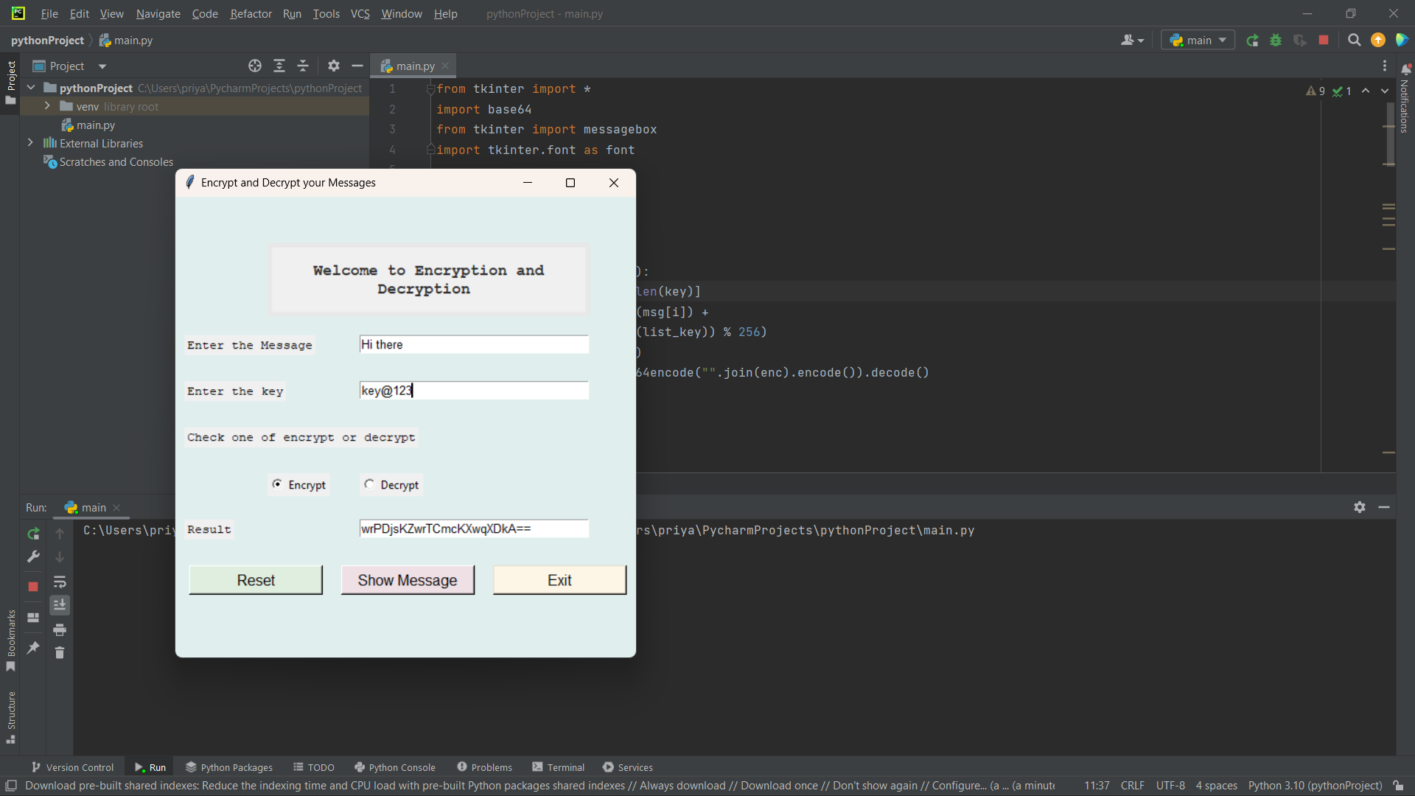

Figure 5.1 Encryption Demo

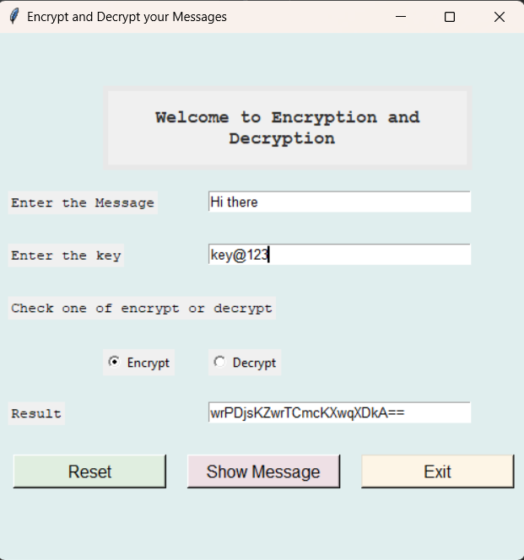

Figure 5.2 Encryption Result

**Decryption:**

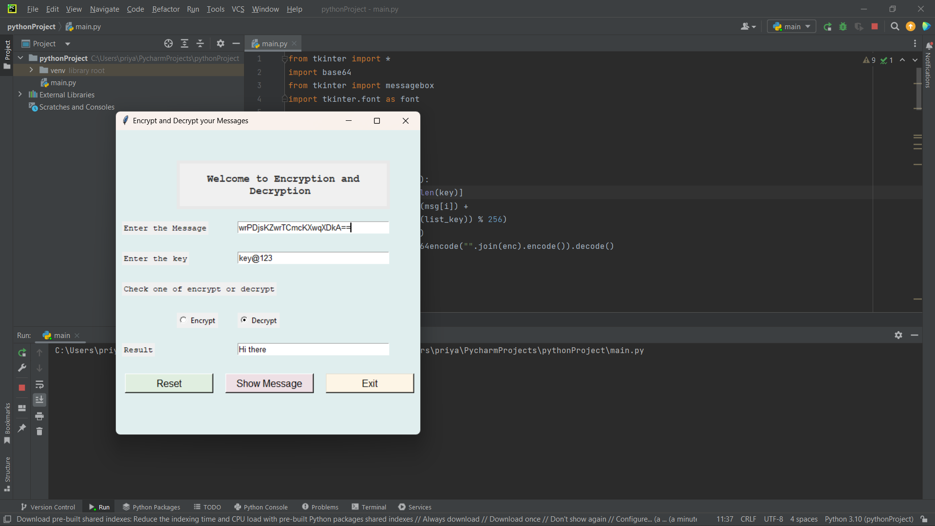

Figure 5.3 Decryption Demo

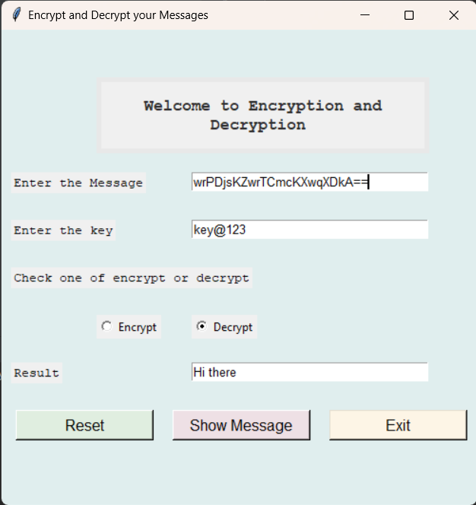

Figure 5.4 Decryption Result

**CHAPTER 6**

**CONCLUSION AND FUTURE WORK**

**CONCLUSION:**

In conclusion, the message encryption and decryption project using Python and the Tkinter module provides a secure way of encoding and decoding messages. The project involves installing the necessary modules, importing them into the project, writing functions for encryption and decryption, creating the window, adding the input and output components, and adding the buttons and their functions. By following these steps, the developer can build a user-friendly interface that allows the user to input the message and encryption key and output the encrypted or decrypted message.

This project is useful for anyone who wants to transmit sensitive information securely. The encryption function converts the text into an incognizable language that can only be decrypted using the same encryption key. This ensures that the message is only readable by the intended recipient. The project also provides an excellent opportunity for developers to improve their skills in Python and the Tkinter module.

Overall, the message encryption and decryption project is a valuable tool for anyone who values data security and confidentiality. With the increasing prevalence of cyber-attacks, this project provides a practical solution for encrypting and decrypting messages to protect sensitive information.

**6.1 FUTURE WORK:**

There are several potential avenues for future work on the message encryption and decryption project using Python and the Tkinter module. Here are some possibilities:

**1. Additional encryption algorithms:** The current project uses the base64 module to encrypt and decrypt messages. However, there are other encryption algorithms, such as Advanced Encryption Standard (AES) or Rivest-Shamir-Adleman (RSA), which may be more secure and provide additional options for the user.

**2. Graphical user interface (GUI) improvements**: While the current project provides a basic GUI for the user to input and output data, there is room for improvement in terms of user experience and interface design. For example, adding more user-friendly options for inputting the encryption key or improving the layout and design of the window.

**3. Integration with other applications:** The message encryption and decryption project could be integrated with other applications, such as email or messaging platforms, to provide a seamless and secure way of transmitting sensitive information.

**4. Error handling:** The current project assumes that the user inputs the correct data and key. However, in real-world scenarios, errors may occur, such as entering the wrong encryption key. Future work could focus on improving error handling and providing more informative error messages for the user.

**5. Multi-platform support:** Currently, the project is built for the Python platform. However, future work could focus on making the project compatible with other platforms, such as Java or C++, to reach a wider audience.

In summary, there are many potential avenues for future work on the message encryption and decryption project. These include improving encryption algorithms, enhancing the user interface, integrating with other applications, improving error handling, and providing multi-platform support. These enhancements could make the project more useful and accessible to a wider audience.

**CHAPTER 7:**

**REFERENCES**

1. <https://www.academia.edu/85028006/Encryption_and_Decryption_Technique_for_Message_Communication?sm=b>
2. <https://www.academia.edu/76112256/Aes_and_Rsa_Based_Hybrid_Algorithms_for_Message_Encryption_and_Decryption?sm=b>
3. <https://www.tutorialspoint.com/cryptography_with_python/cryptography_with_python_quick_guide.htm>
4. <https://www.tutorialspoint.com/cryptography_with_python/cryptography_with_python_base64_encoding_and_decoding.htm>
5. <https://www.tutorialspoint.com/python/python_gui_programming.htm#:~:text=Tkinter%20is%20the%20standard%20GUI,to%20the%20Tk%20GUI%20toolkit.&text=Import%20the%20Tkinter%20module>

Top of Form